Modes

# Add / Delete Mode

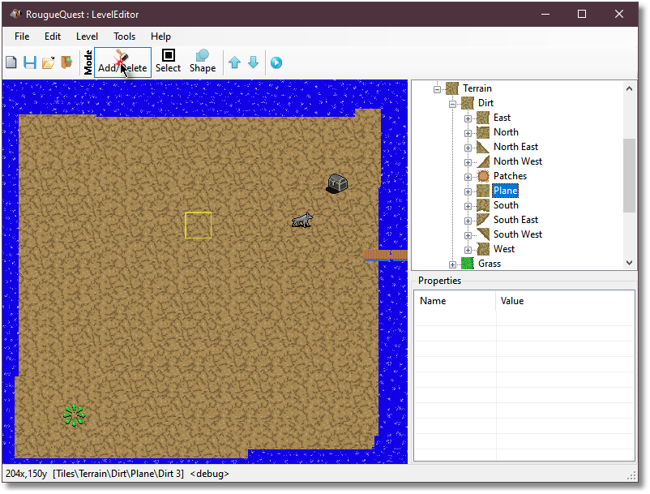

When in **add/delete** mode, you can **left-click with the mouse** to add a single tile of the type selected in the materials browser.

If you have a folder selected instead of a single tile then the editor will use a random tile from the folder. This is useful when drawing plains such as dirt, grass and ocean because it will create a non-uniform plain and look more natural.

**Dragging with the left mouse button** down will “paint” with the selected material.

**Clicking with the right-mouse button** will delete the highlighted tile, while **dragging with the right mouse button** delete all tiles that the mouse hovers over acting like an eraser brush.

# Select mode

# 

When in select mode you can **single left click the mouse** to select a single tile and then left click drag it.

With the **right mouse button**, you can drag to select multiple tiles.

Holding the **shift** key while dragging the right mouse button or while single clicking the **right mouse button** allows you to add more sections to the selected tiles.

Holding the **control** key while dragging the right mouse button or while single clicking the **right mouse button** allows you to remove more sections to the selected tiles.

Once you have the desired tiles selected, you can **left click them with the mouse** to drag them to a new location.

**Left or right mouse clicking** anywhere else on the map without holding **shift** or **control** will deselect all selected tiles, as will changing the mode.